**Title:- Implementation of 4 :1 Multiplexer using Data flow modelling**

**Code**

---------------------------------------------------------------------------------

-- Company:

-- Engineer:

--

-- Create Date: 15:05:22 09/24/2015

-- Design Name:

-- Module Name: mux4to1 - Behavioral

-- Project Name:

-- Target Devices:

-- Tool versions:

-- Description:

--

-- Dependencies:

--

-- Revision:

-- Revision 0.01 - File Created

-- Additional Comments:

--

----------------------------------------------------------------------------------

library IEEE;

use IEEE.STD_LOGIC_1164.ALL;

use IEEE.STD_LOGIC_ARITH.ALL;

use IEEE.STD_LOGIC_UNSIGNED.ALL;

---- Uncomment the following library declaration if instantiating

---- any Xilinx primitives in this code.

--library UNISIM;

--use UNISIM.VComponents.all;

entity mux4to1 is

Port ( a : in STD_LOGIC;

b : in STD_LOGIC;

c : in STD_LOGIC;

d : in STD_LOGIC;

s1 : in STD_LOGIC;

s0 : in STD_LOGIC;

y : out STD_LOGIC);

end mux4to1;

architecture Behavioral of mux4to1 is

begin

y<= (not s1 and not s0 and a)or (not s1 and s0 and b)or (s1 and not s0 and c) or ( s1 and s0 and d);

end Behavioral;

**RTL Schematic**

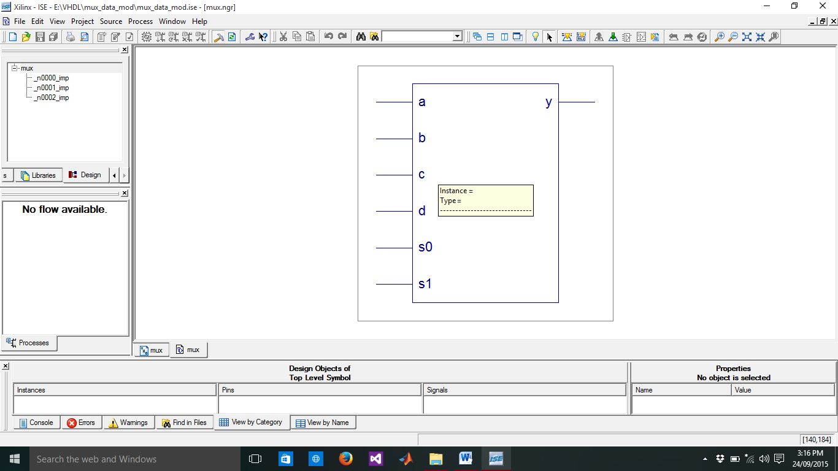

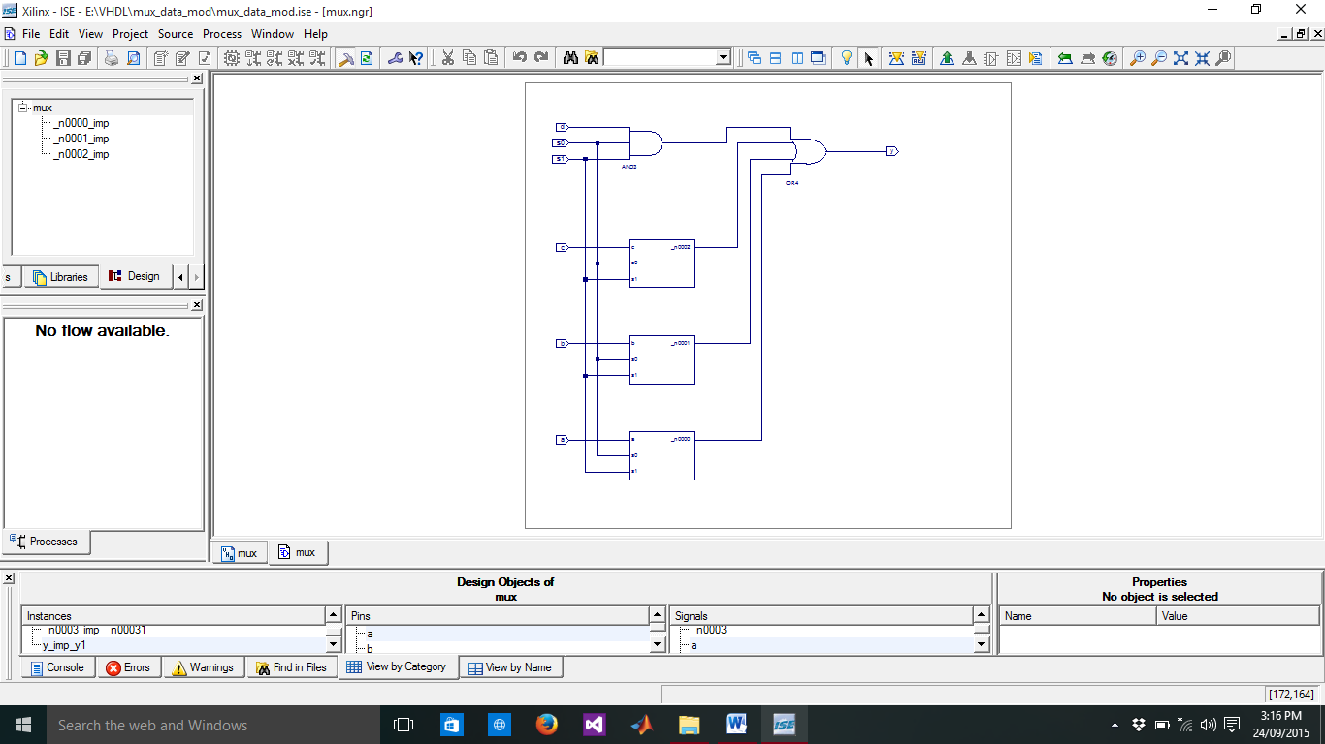

**Technology Schematic**

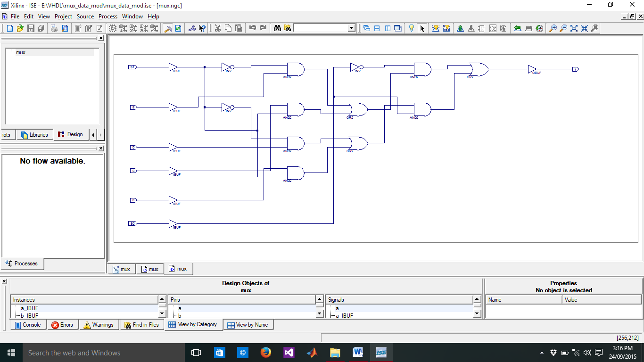

**Input Waveforms**

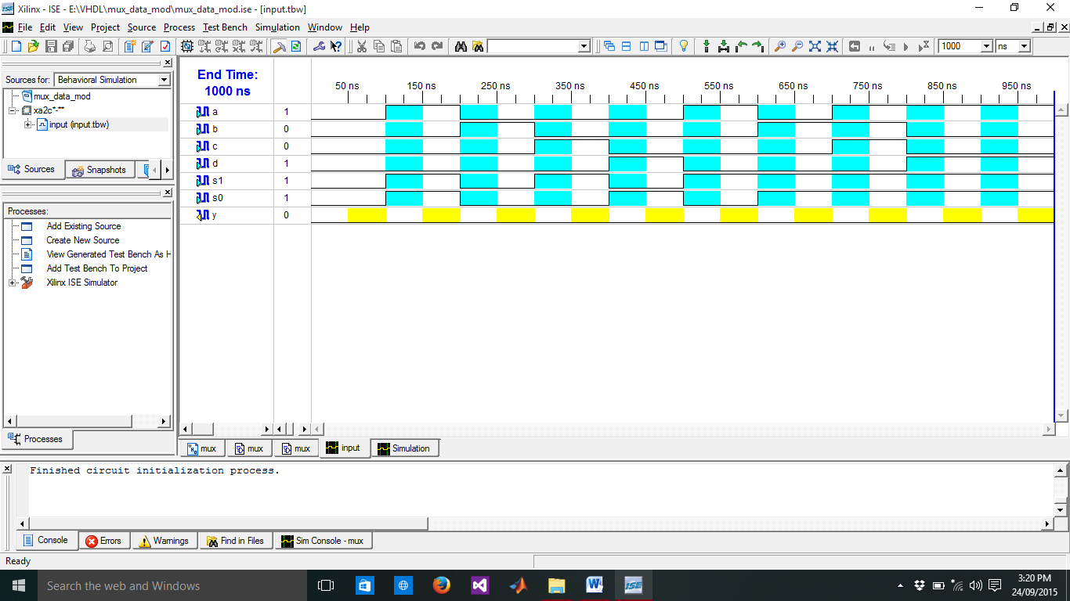

**Output Waveforms**

